JMeter – Selenium Webdriver Inegration

Pre-requisites:

1. Download the Jmeter web driver sampler (jmeter-plugins.org)
2. Unzip the file (jpgc-webdriver-x.x.x.x)
3. Copy the lib folder to the apache-jmeter-x.x lib folder (selenium webdriver libraries)
4. Download the chromedriver (chromedriver.chromium.org)
5. Unzip the file (chromedriver_win64)
6. Copy the .exe and license the apache-jmeter-x.x license folder (chromedriver license)
7. Open jmeter using cmd: C:\Users\user\apache-jmeter-5.6.3\bin>jmeter.bat
8. Right-click Test Plan> and go to Thread Group

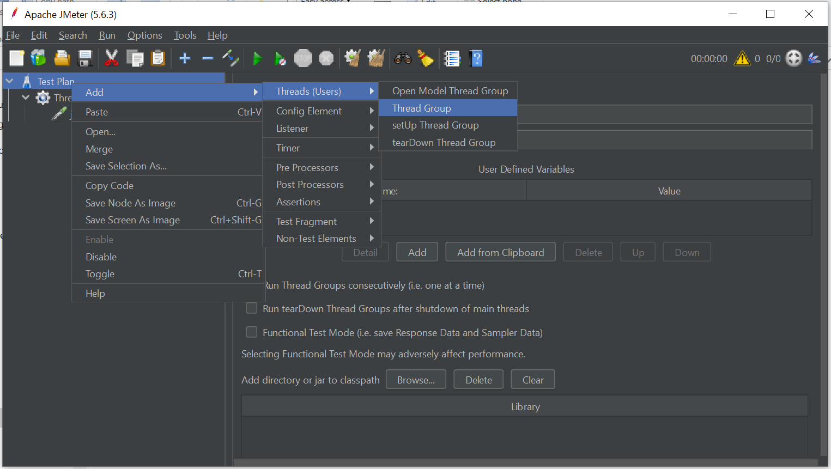

1. Right-click Thread Group and WebDriver Sampler

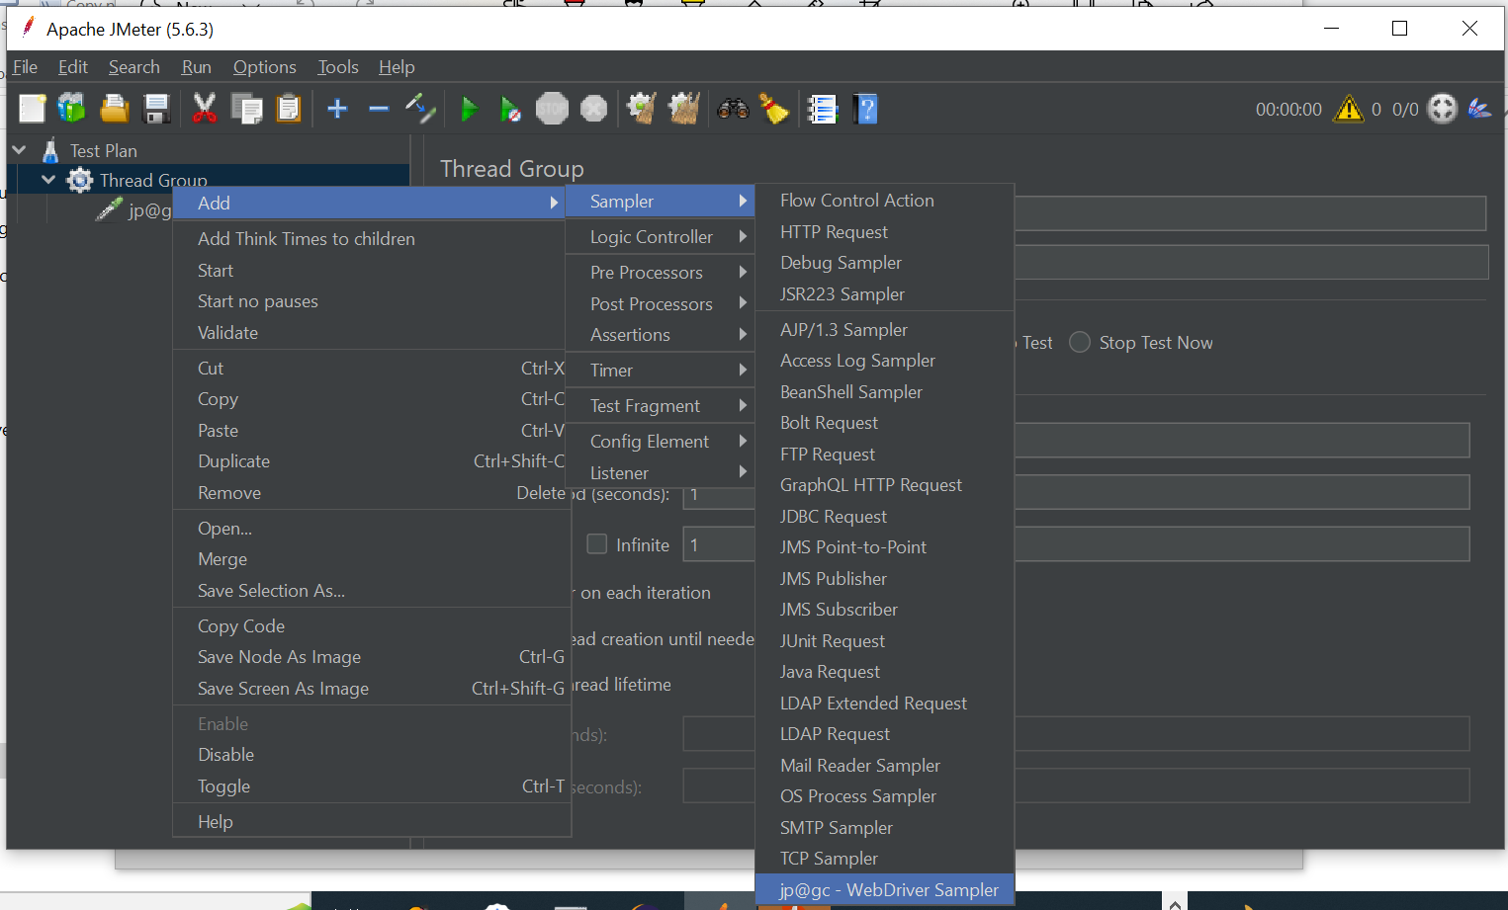

1. Right-click Thread Group and add Chrome Driver Config

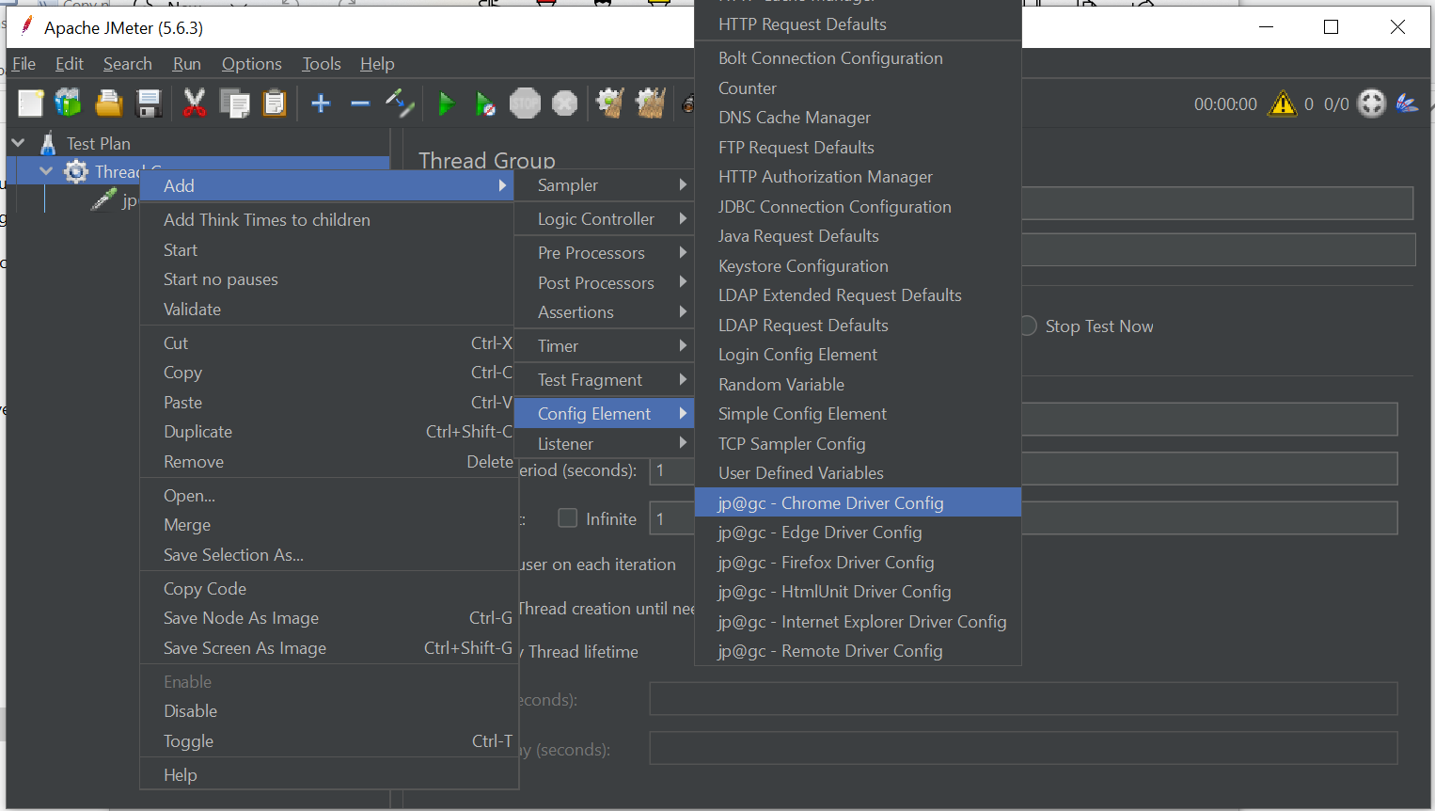

Add the chromedriver.exe path to the Chrome Driver Config

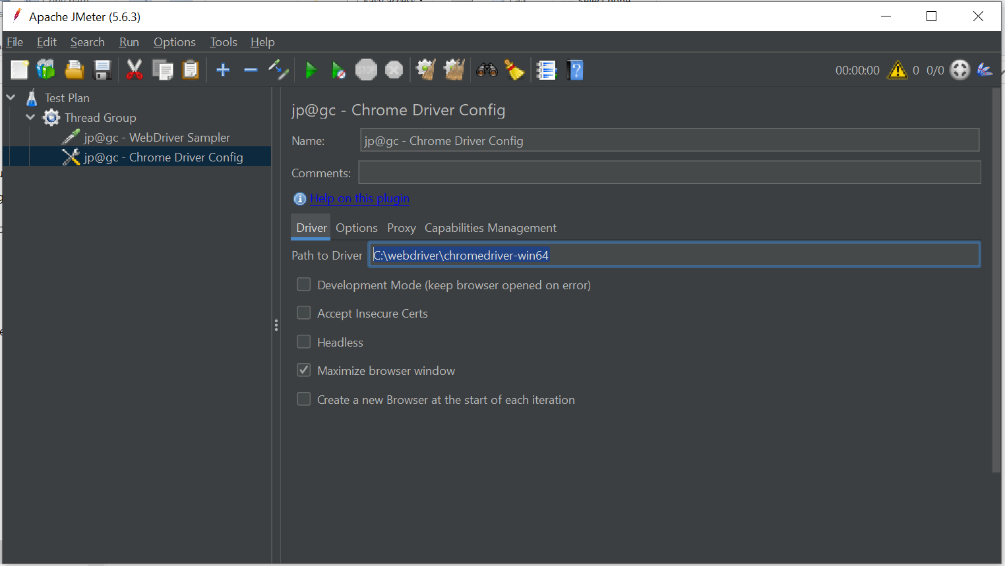

Add listeners (View Results Tree)

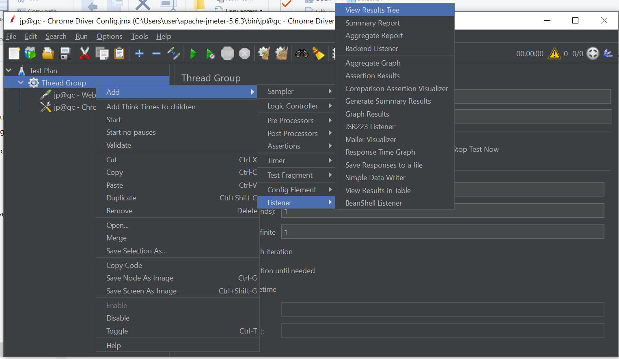

Add another listener (View Results in Table)

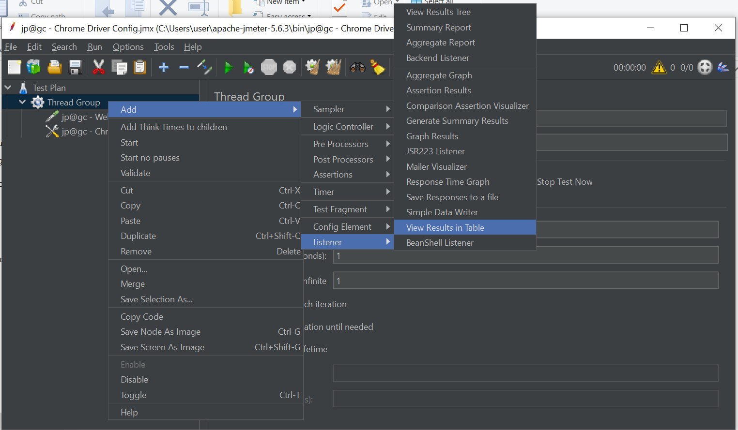

Go to WebDriver Sampler and start writing the code. Save the project.

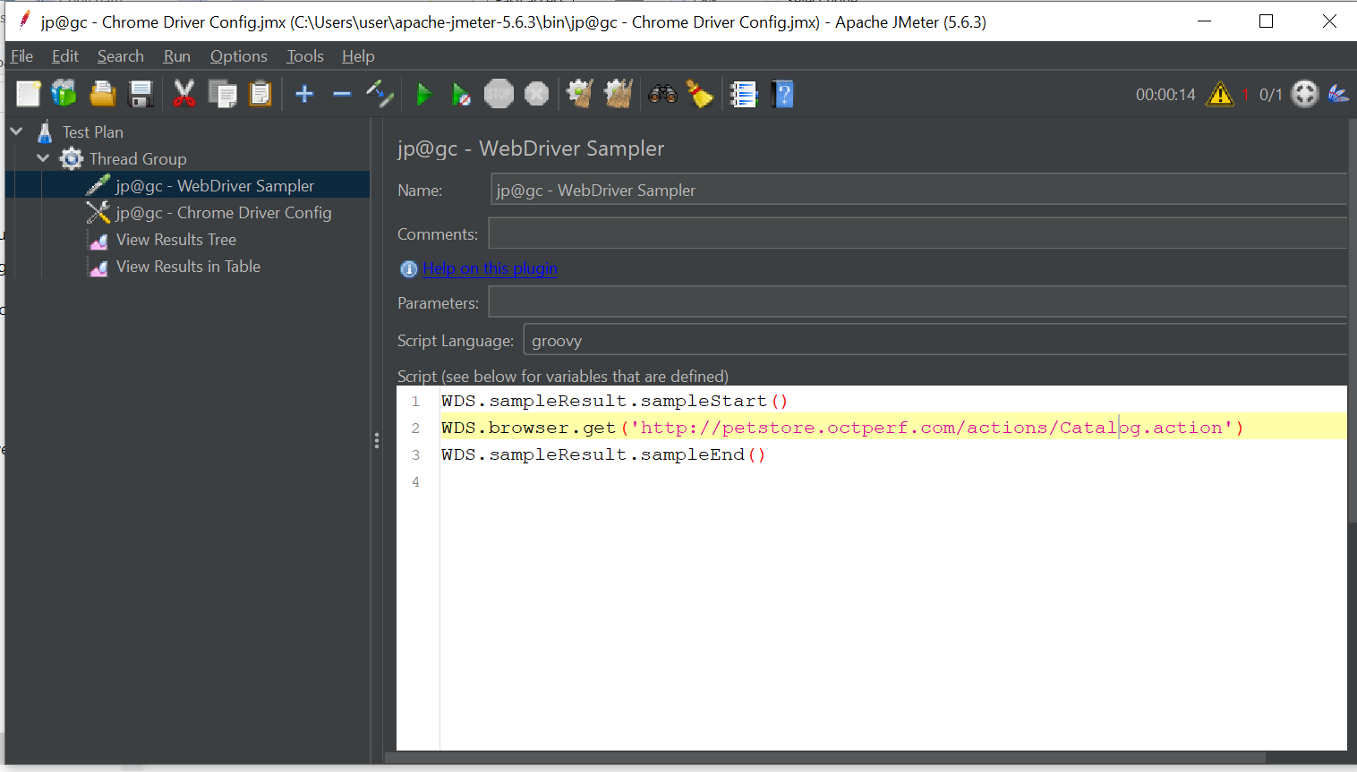

Press the run button to execute the code.

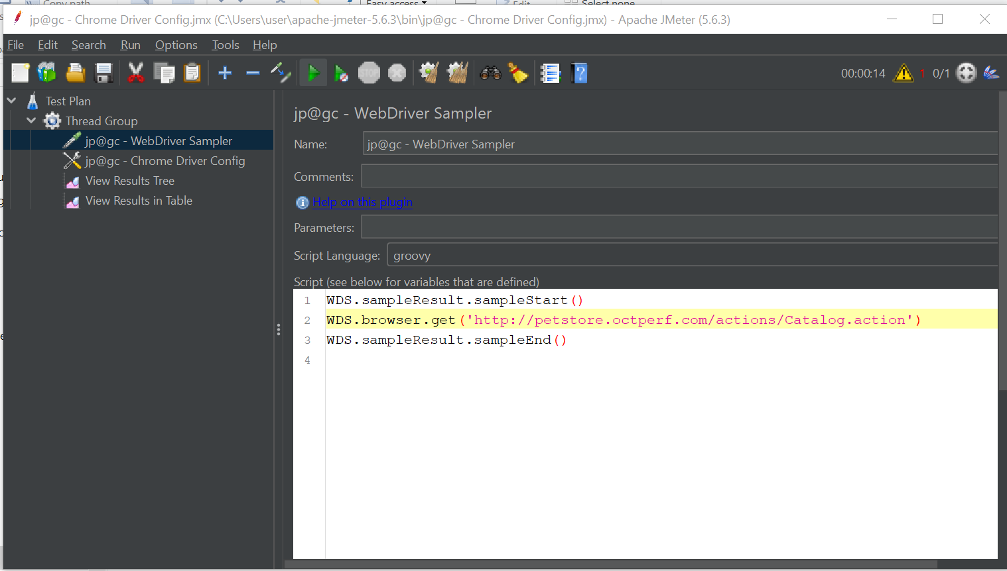

Create a CSV file with your category and save it under your current project.

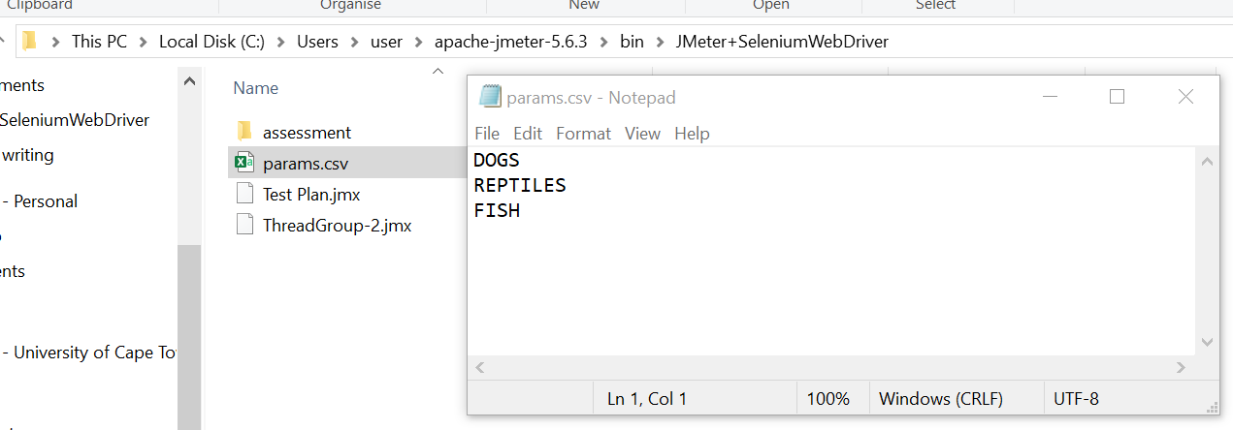

Right-click WebDriver Sampler and add CSV Data Set Config for parameterization

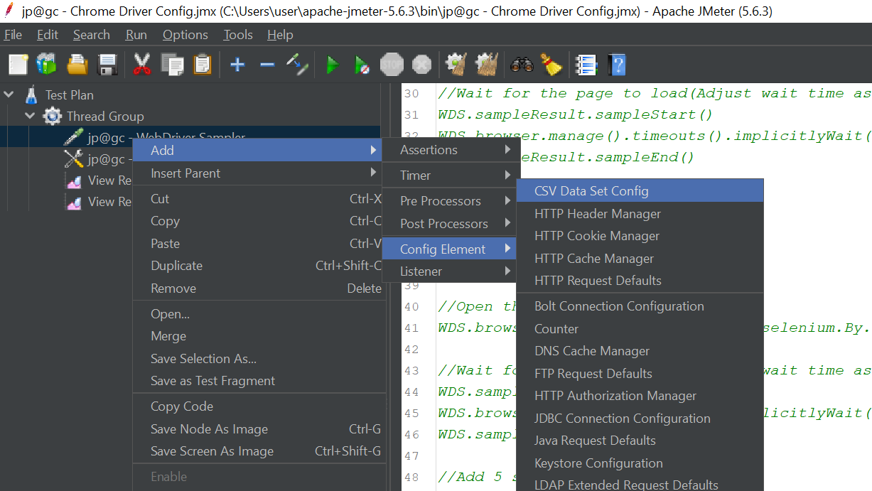

Click on the Browse button to navigate to your project folder, add your CSV file and add the variable Names (category). This will be used on the code.

You can go to thread properties to adjust the loop count and number of concurrent users

